# UltraMSK

The UltraMSK is used to remotely sense the bottom side of the ionosphere for magnetospheric disturbances. The instrument records the phase and amplitude of minimum shift keying (MSK) modulated narrow band signals. There are number of transmitters worldwide, of which signal is received from 7 at SANAE IV. Because of SANAE IV’s position relative to the global VLF transmitters, signals originating from the east or west travel a great distance over the Antarctic ice mass, as illustrated in *Figure 1*.

Transmitters have been chosen based on the propagation path from Tx to Rx. Paths are for different science purposes. In general, the signals received from these transmitters will change in a semipredictable manner throughout the day (during the diurnal cycle), however, certain space weather events such as solar flares will have an immediate effect on the MSK signals.

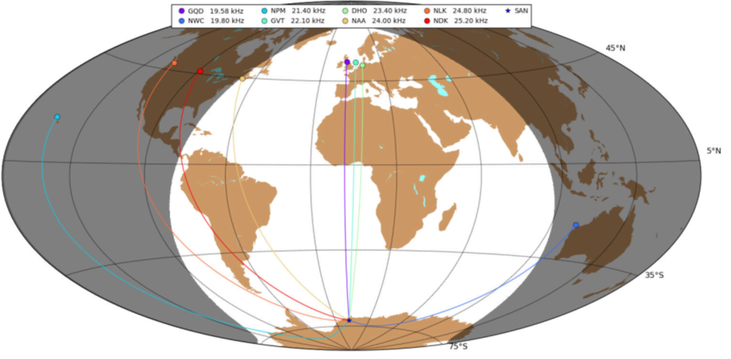

Figure 1. Great circle paths from various minimum shift keying transmitters to SANAE IV.

UltraMSK is installed in parallel with the WWLLN System on the same PC. A magnetic loop antenna located a few hundred meters from SANAE IV was used for this purpose. The antenna consists of two vertically mounted diamond shaped loops with sides of length 7.6 m, aligned with the four cardinal directions. The loop facing north–south is a better choice for monitoring signals of European origin, whereas the east–west loop is more sensitive to signals propagating zonally.

A preamplifier at the base of the antenna boosts the signal, which is transmitted to the laboratory via a lengthy coaxial cable. The signal is passed through a second amplifier before reaching the service unit. From here the signal is transferred to the sound card on a personal computer. The service unit also integrates GPS timing. The phase of the signal is determined by a quadrature-phase mixer, where the received signal is split and mixed with an in-phase component on one hand and a quadrature-phase component on the other.

After the signals have been demodulated, the two components can be compared and information regarding the phase and amplitude of the signal can be extracted. To achieve a reliable centre frequency for the quadrature phase mixer, the precise sampling frequency of the sound card is calibrated using the pulse-per-second signal from the GPS. The system runs at a sampling rate of 96 kHz, and the signal intensity and phase are recorded at 20 Hz. UltraMSK is a VLF narrowband receiver designed to measure both the amplitude and phase of modulated VLF signals.

Data from several M-class and C-class solar flares illustrate the response of the instrument, and from these measurements the characteristics of the D-region can be modelled. Energy exchange between the magnetosphere and the surrounding solar wind is a continuous process which is enhanced during periods of increased solar activity. Coronal mass ejections and solar flares release an enormous number of highly energetically charged particles which are transported through the solar wind to Earth. These particles are accompanied by X-ray bursts, which are harmful to satellites, spacecraft, and astronauts. These events have an appreciable impact on the Earth’s ionosphere. This radiation penetrates down into the lower ionosphere and leads to sudden ionospheric disturbances.12 Solar flares cause a broad increase in plasma density in the dayside ionosphere, which in turn affects VLF signals propagating in the EIWG, as can be seen in *Figure 2*.

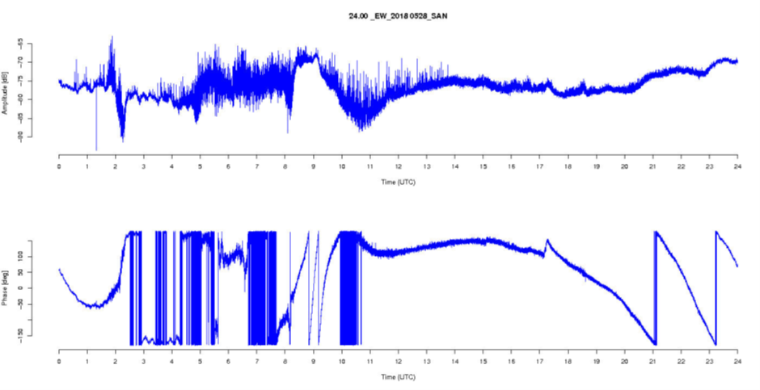

Figure . Solar flares.

The attenuation of the signal is higher during the day because of the lower conductivity of the D-region compared to the E-region at night. The average daytime signal amplitude is about -65 dB, compared to -57 dB at night.